Representation 1 | Representation 2 | Double
Double ___ is ___
___+___=
____x___=
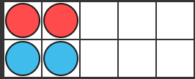 |  | Double ___ is ___  ___+___=  ____x___=
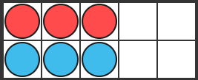 |  | Double ___ is ___  ___+___=  ____x___=
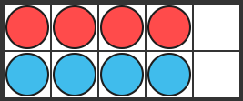 |  | Double ___ is ___  ___+___=  ____x___=
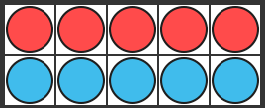 |  | Double ___ is ___  ___+___=  ____x___=
Double ___ is ___
___+___=
____x___=
Double ___ is ___
___+___=
____x___=

